DBS311 D - Lab 1 – In-Lab submission only, unless you have a permission from me to submit by e-mail. Your Word or TXT Document must have both SELECT statements and the OUTPUTS. You may also submit your Lab Printout to our Reception Office, Room A3058 by the due date, Thursday, January 25 by 4pm
Use DEMO tables here → LOCATION, DEPARTMENT, EMPLOYEE

1. Write a query to display the After-tomorrow’s date in the following format:
September 28th of year 2016
Your result will depend on the day when you create this query.
Label the column After Tomorrow.
Answer;
SELECT
TO_CHAR(SYSDATE + 2, 'Month ddth "of year" YYYY') AS "After Tomorrow"
FROM dual;

Output;
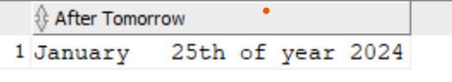
2. For each employee in departments 50 and 60 display last name, first name, salary, and salary increased by 7% and expressed as a whole number.
Label the column Good Salary.
Also add a column that subtracts the old salary from the new salary and multiplies by 12. Label the column Annual Pay Increase.
Answer;
SELECT
last_name,first_name,salary,
ROUND(salary + (salary * 0.07)) AS "Good Salary",
ROUND(((salary + (salary * 0.07))-salary) * 12) AS "Annual Pay Increase"
FROM employee
WHERE department_id IN (50, 60);

Output;
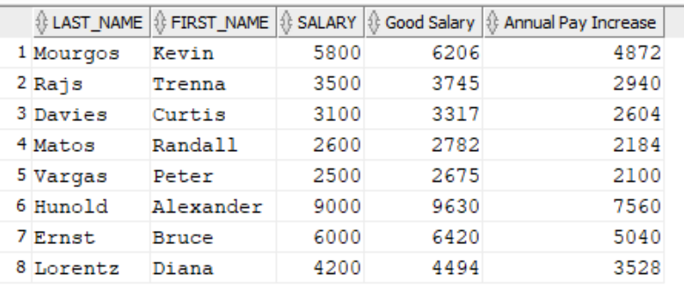

3. Write a query that displays the employee’s Full Name and Job Title in the following format:
DAVIES, CURTIES is Stock Clerk
for all employees whose last name ends with S and first name starts with C or K.
Give this column an appropriate label like Person and Job
Sort the result by the employees’ last names.
Answer;
SELECT UPPER(last_name ||', '||first_name)||' is '||job_id AS "Person and Job"
FROM employee
WHERE (UPPER(last_name) LIKE '%S' AND (UPPER(first_name) LIKE 'C%' OR UPPER(first_name) LIKE 'K%'))
ORDER BY last_name;

Output;
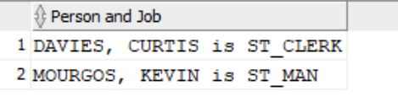

4. For each employee hired before 1992 who is earning more than $10000, display the employee’s last name, salary, hire date and calculate the number of YEARS between TODAY and the date the employee was hired. Round the number of years up to the closest whole number. Label the column Years Worked.
Order your results by the highest paid people first, then by years worked.
Answer;
SELECT last_name,salary,hire_date,
ROUND(MONTHS_BETWEEN(SYSDATE, hire_date)/12) AS "Years Worked"
FROM employee
WHERE hire_date < to_date('1992-01-01','YYYY-DD-MM') AND salary>10000
ORDER BY salary DESC,"Years Worked";
Output;
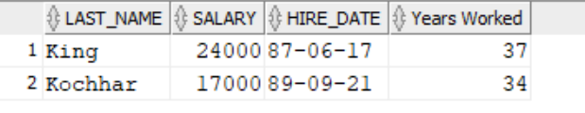
5. Create a query that displays the city names, country codes and state province names, but only for those cities that start on S and have at least 8 characters in their name. If city does not have province name assigned, then put Unknown Province.
Answer;
SELECT city,country_id,NVL(state_province,'Unknown Province') AS "State_Province"
FROM Location
WHERE city LIKE 'S%' AND LENGTH(city) >=8;
Output;

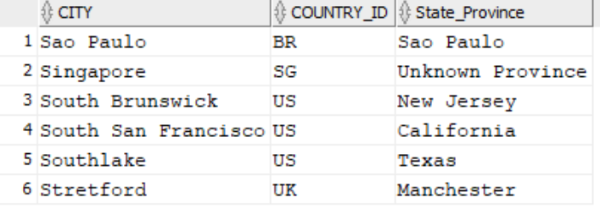

6. Display each employee’s last name, hire date, and salary review date, which is the first Tuesday after a year of service, but only for those hired after 1997.
Label the column REVIEW DAY. Format the dates to appear in the format similar to: TUESDAY, August the Thirty-First of year 1998

Answer;
SELECT last_name, hire_date,
TO_CHAR(NEXT_DAY(hire_date + INTERVAL '1' YEAR, 'TUESDAY'), 'FMDAY, Month "the" fmDdspth "of year" YYYY') AS "REVIEW DAY"
FROM employee
WHERE hire_date > TO_DATE('1998-01-01', 'YYYY-MM-DD');

Output;
